A2620-Pac-Poly-Rapa Nui–Rongorongo-Similar to Aruku Fischer RR4-Toromiro Wood-c 1200 CE

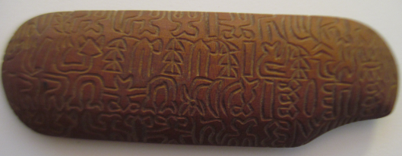

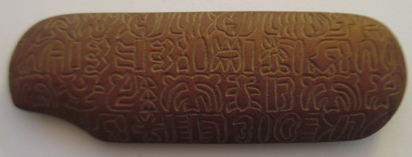

Figs. 1-2, Recto and Verso**:** Pac-Poly-Rapa Nui–Rongorongo-Similar to Aruku Fischer RR4-Toromiro Wood-c 1200 CE

**Case no.: 13**

**Accession Number: A2620**

**Formal Label:** Pac-Poly-Rapa Nui–Rongorongo-Similar to Aruku Fischer RR4-Toromiro Wood-c 1200 CE

**Display Description:**Oblong carved board from the indigenous Rapa Nui hardwood of the *toromiro* tree. It has rounded edges, with one edge is indented like a handle. Rongorongo texts comprise lines of outlined motifs of zoomorphs, botanomorphs, anthropomorphs and each successive line reverses direction, which is called boustrophedon or the way an ox turns back on itself with each successive plowed row. This is an abbreviated rongorongo text with only 4 lines per side.Extant rongorongo inscriptions number some 24 texts shallowly carved into irregularly shaped pieces of wood, a chieftain's staff, a bird-man statuette, and two “rei miro” or Polynesian canoe pectorals and a few petroglyphs. Some of these are damaged by use or interment and all were collected in the late 19th century and apart from the petroglyphs are now in museums, private collections, but none are on Easter Island. Due to the paucity of preserved rongorongo texts, literacy probably was restricted to a priestly élite. As of 2018 the Easter Island Script has not been deciphered.

**LC Classification:**F3169 F48

**Date or Time Horizon:** c 1200 CE

**Geographical Area:** Rapa Nui

**Map:**

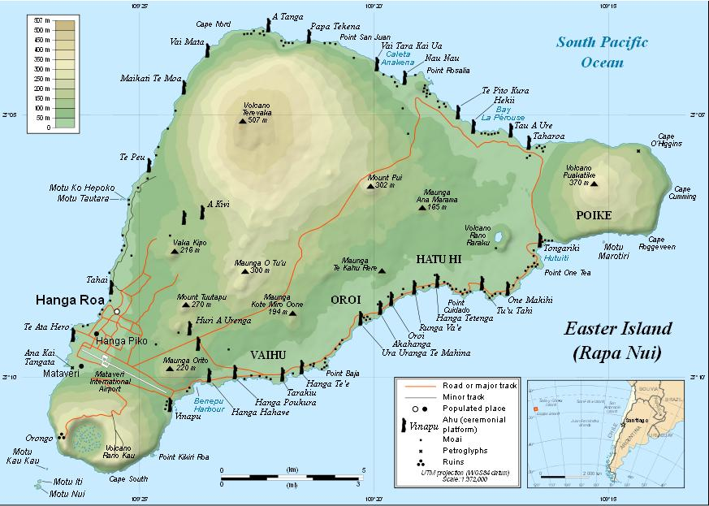

**GPS coordinates:**

**Cultural Affiliation:** Polynesian

**Medium:** Toromiro Wood

**Dimensions:** L176.79 mm, 6,96 in; W 58.14 mm, 2.29 in; T 19.55 mm, 0.77 in

**Weight: 81 gm, 2.75 oz**

**Condition: original**

**Provenance:** Santiago, Chile

**Discussion:**

**References:**

|  |  |  |  |
| --- | --- | --- | --- |
| Author | Title | Journal | |
| J. Park Harrison | Hieroglyphic Tablets and Sculpture in Easter Island | | Nature 10 (1874) |
| A. Carroll, M.A., M.D. | The Easter Island inscriptions,   and the translation and interpretation of them. | | Journal of the Polynesian society 1 (1892) | |
| A. Carroll. | Easter Island Inscriptions. | | Journal of the Polynesian society 6 (1897) | |
| T. W Downes. | History of NGATI-KAHU-NGUNU. | | Journal of the Polynesian society 23 (1914) | |
| H. T. Whatahoro | The Lore of the Whare-Wananga.   TE KAUWAE-RARO | | Journal of the Polynesian Society 24 (1915) | |
| W. W. Thopre | An Inscribed Wooden Gorget from Rapanui | | Journal of The Polynesian Society 33 (1924) | |
|  | Undeciphered Scripts | | Nature 130 (1932) | |
| H. D. Skinner | The Easter Island Script | | Journal of the Polynesian Society 41 (1932) | |
| H. D. S. | Easter Island Script and the Script of Mohenjo-daro. | | Journal of the Polynesian society 43 (1934) | |
| Ralph Piddington | A Note on the Validity and Significance of Polynesian Traditions | | Journal of the Polynesian Society 65 (1936) | |
| Dr. Alfred Metraux | The Kings of Easter Island | | Journal of the Polynesian society 46 (1937) | |
| Sr. J. Imbelloni | Recent discoveries in the middle-Indus area and their relation to the Easter Island Script. | | Journal of the Polynesian society 48 (1939) | |
| E. S. Craighill Handy. | Perspectives in Polynesian religion | | Journal of the Polynesian society 49 (1940) | |
| J. C. A. | [Review] of "The script of Mohenjo-daro and Easter island." | | Journal of the Polynesian society 50 (1941) | |
| P. A. Lanyon-Orgill | The Easter island Scrip. | | Journal of the Polynesian society 51 (1942) | |
| Werner Wolff | The Mystery of the Easter Island Script | | Journal of the Polynesian Society 54 (1945) | |
| Werner Wolff | Three Mysteries of Easter Island | | Scientific American 180 (1949) | |
| Donald Stanley Marshall | The Settlement of Polynesia | | Scientific American 195 (1956) | |
| N. A. Butinov and Y. V. Knorozov. | Preliminary report on the study of the written language of easter island | | Journal of the Polynesian society 66 (1957) | |
| Thomas S. Barthel | The "Talking Bords" of Easter Island | | Scientific American 198 (June, 1958) | |
| Thomas S. Barthel | Female stone figures on Easter Island | | Journal of the Polynesian society 67 (1958) | |
| N. A. Butinov | [Review] of "grundlagen zur Entzifferung der Oster-Inselschrift." | | Journal of the Polynesian society 68 (1959) | |
| Thomas S. Barthel. | Easter Island Place-Names. | | Journal de la sociéteé des océanistes 18 (1962) | |
| Kenneth P. Emory | Settlement Pattern and Time Involved as Indicated by Vocabulary Agreements | | Journal of the Polynesian society 72 (1963) | |
| William Mulloy, Arne Skjölsvold and Carlyle S. Smith | Easter Island: Reply to Barthel's Review | | American Anthropologist 66 (1964) | |
| Kenneth Emory | [Review] of "Reports of the Norwegian Archaeological Expediton to Easter Island and the East Pacific." | | American Anthropologist 70 (1968) | |
| Kenneth P. Emory | Easter Island’s Position in the Prehistory of Eastern Polynesia | | Journal of the Polynesian society 81 (1972) | |
| Patrick C. McCoy | The Place of Near-Shore Islets in Easter Island Prehistory | | Journal of the Polynesian Society 87 (1978) | |
| Paul Geraghty | [Review] of  "Captain Cook's South Sea Island Vocabularies" | | Journal of the Polynesian society 90 (1981) | |
| Jacques B. M. Guy | Fused Glyphs in the Easter Island Script | | Journal of the Polynesian society 91 (1982) | |
| Ross Clark | [Review] of "The Language of Easter Island" | | Journal of the Polynesian society 92 (1983) | |
| J. R. Flenley & Sarah M. King | Late Quaternary pollen records from Easter Island | | Nature 307 (1984) | |
| Jacques B. M. Guy | On a fragment of the "TAHUA" tablet | | Journal of the Polynesian society 94 (1985) | |
| Patrick V. Kirch | Rethinking East Polynesian Prehistory | | Journal of the Polynesian Society 95 (1986) | |
| Jacques B. M. Guy | Rjabchikov's Decipherments Examined | | Journal of the Polynesian society 97 (1988) | |
| Sergej V. Rjabchikov | Allographic Variations of Easter Island Gryphs | | Journal of the Polynesian Society 97 (1988) | |
| Jacques B. M. Guy | À propos des mois de l'ancien calendrier pascuan | | Journal de la sociéteé des océanistes 94 (1992) | |
| Steven Roger Fischer | Rapanui's "Great old words":E TIMO TE AKOAKO | | Journal of the Polynesian society 103 (1994) | |
| Steven Roger Fischer | Rapanui's Tu'u ko Iho Versus Mangareva's 'Atu Motua | | The Journal of Pacific History 29 (1994) | |
| Erika Hagelberg et al. | DNA from ancient Easter Islanders | | Nature 369 (1994) | |
| Steven Roger Fischer | Preliminary evidence for cosmogonic texts in Rapanui’s rongorongo inscriptions | | Journal of the Polynesian society 104 (1995) | |
| Paul G. Bahn | Making sense of rongorongo | | Nature 379 (1996) | |
| Steven Roger Fischer | Easter Island's `Deed of Cession' of 1770 and the origin of its Rongorongo Script by Robert Langdon | | Journal of the Polynesian Society 105 (1996) | |
| Paul Bahn | Cracking the Easter Island code | | New Scientist 20 (1996) | |

**Books**

|  |  |  |
| --- | --- | --- |
| Author | Title | **Publisher** |
| Katherine Routledge | The Mystery of Easter Island | Adventures Unlimited Press |
| Catherine and Michel Orliac | Easter Island--Mystery of the Stone Giants | Harry N. Abrams, INC. |
| Steven Roger Fischer | Rongorongo--the Easter Island Script | Oxford University Press |